|  |  |  |  |  |  |  |  |
| --- | --- | --- | --- | --- | --- | --- | --- |
| Pre-Start Meeting Conducted By: |  | | Signature: |  | | Date: | Time: |
| Scope of Works for Shift: |  | | | | | /    / | :    am / pm |
| Site/ Project (incl. location): |  | Nearest Hospital: |  | | https://upload.wikimedia.org/wikipedia/commons/thumb/0/0e/ISO_7010_E003_-_First_aid_sign.svg/2000px-ISO_7010_E003_-_First_aid_sign.svg.png First Aid Officers: |  | |
| Site Emergency Contact |  | Emergency Evac Point |  | | | | |

**High Risk tasks** (mark applicable for shift)**:**  Excavation/ Trenching,  Hot Work,  Working at Heights,  Confined Spaces,  Working near Overhead Services,  Electrical Work,  Working near Traffic,  Working in the vicinity of Mobile Plant,  Operation of powered plant or equipment,  Working in Isolation,  Hazardous Manual Handling,  Asbestos Removal,  Working within Rail Corridor,  Handling/ Transporting Hazardous Substances and Dangerous Goods,  Isolation Testing and Tagging,  Working near or over Water,  Crane Operation and Rigging,  Rail Crossings Utilised,  Work in Proximity to Environmentally Sensitive Areas  Other _________________________________

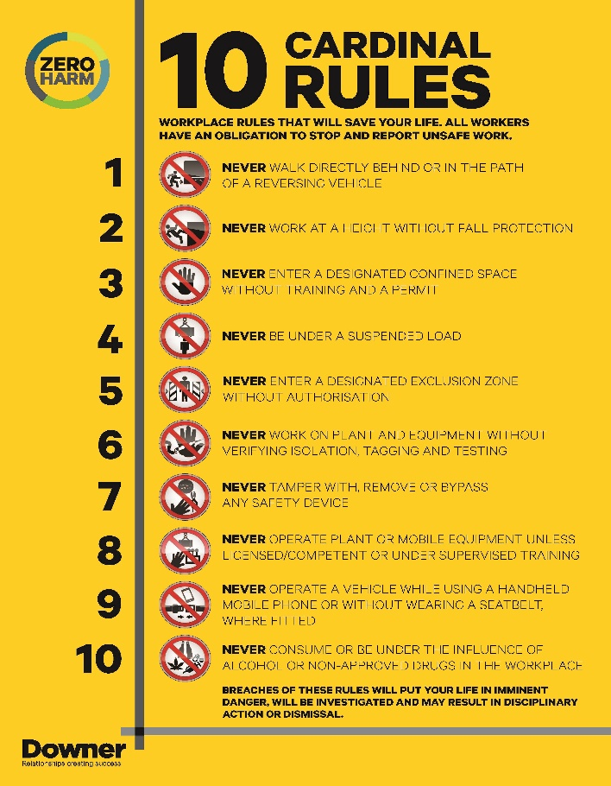

|  |  |  |
| --- | --- | --- |
| Item No. | **Requirement** | **Yes / No N/A** |
| **1** | Are controls in place to ensure personnel working in the vicinity of mobile plant and public vehicles are safe?ie. Restricted Access, Barriers, Exclusion Zones, Traffic Control, (Rail) Track Protection, etc... **Remember the minimum Exclusion Zones around Mobile Plant** |  |
| **2** | Is reversing on site kept to a minimum and has a designated spotter been assigned? |  |
| **3** | Is there adequate protection around Open Pits / Trenches, Excavations etc? |  |
| **4** | Have all services been identified (Overhead and Underground)? For the identification of Underground Services, has a **Dial before you Dig** been undertaken? |  |
| **5** | Are controls in place to minimise your impact to the environment? i.e. Clean water diversions, erosion and sediment control, bunding of chemicals, vegetation disturbance in approved areas only, avoid heritage sites, appropriate spoil dumpsites identified. |  |
| **6** | For all high risk tasks identified above, has a SWMS been developed and a permit completed (where applicable)? |  |
| **7** | Do all personnel understand the requirements of SWMS in use and signed off? |  |
| **8** | Is all equipment fit for purpose and in good working condition? (incl. completion of Pre-Start Checks) **If not, has it been removed, Isolated/ Tagged out?** |  |
| **9** | Are all plant operators or trades onsite licensed, competent and fit for work? Have you verified documents that are required on the Authority to Work Permit (for contractors)? |  |
| **10** | Are all personnel including contractors wearing the appropriate **PPE** for the job? |  |
| **11** | Are Emergency procedures in place and equipment available? |  |
| **12** | Are any adverse weather conditions predicted for the shift? i.e. High temperatures / humidity, storms, flood warnings, etc. (also consider Total Fire Ban Days / Fire Danger Periods) |  |
| **13** | Have residents been notified of work affecting their property and/or routine? |  |

Worksite diagram (zone of understanding)

|  |  |  |  |  |  |  |  |  |  |  |  |  |  |  |  |  |  |  |  |  |  |  |  |  |  |  |  |  |  |  |  |  |  |  |
| --- | --- | --- | --- | --- | --- | --- | --- | --- | --- | --- | --- | --- | --- | --- | --- | --- | --- | --- | --- | --- | --- | --- | --- | --- | --- | --- | --- | --- | --- | --- | --- | --- | --- | --- |
|  |  |  |  |  |  |  |  |  |  |  |  |  |  |  |  |  |  |  |  |  |  |  |  |  |  |  |  |  |  |  |  |  |  |  |
|  |  |  |  |  |  |  |  |  |  |  |  |  |  |  |  |  |  |  |  |  |  |  |  |  |  |  |  |  |  |  |  |  |  |  |
|  |  |  |  |  |  |  |  |  |  |  |  |  |  |  |  |  |  |  |  |  |  |  |  |  |  |  |  |  |  |  |  |  |  |  |
|  |  |  |  |  |  |  |  |  |  |  |  |  |  |  |  |  |  |  |  |  |  |  |  |  |  |  |  |  |  |  |  |  |  |  |
|  |  |  |  |  |  |  |  |  |  |  |  |  |  |  |  |  |  |  |  |  |  |  |  |  |  |  |  |  |  |  |  |  |  |  |
|  |  |  |  |  |  |  |  |  |  |  |  |  |  |  |  |  |  |  |  |  |  |  |  |  |  |  |  |  |  |  |  |  |  |  |
|  |  |  |  |  |  |  |  |  |  |  |  |  |  |  |  |  |  |  |  |  |  |  |  |  |  |  |  |  |  |  |  |  |  |  |
|  |  |  |  |  |  |  |  |  |  |  |  |  |  |  |  |  |  |  |  |  |  |  |  |  |  |  |  |  |  |  |  |  |  |  |
|  |  |  |  |  |  |  |  |  |  |  |  |  |  |  |  |  |  |  |  |  |  |  |  |  |  |  |  |  |  |  |  |  |  |  |
|  |  |  |  |  |  |  |  |  |  |  |  |  |  |  |  |  |  |  |  |  |  |  |  |  |  |  |  |  |  |  |  |  |  |  |
|  |  |  |  |  |  |  |  |  |  |  |  |  |  |  |  |  |  |  |  |  |  |  |  |  |  |  |  |  |  |  |  |  |  |  |
|  |  |  |  |  |  |  |  |  |  |  |  |  |  |  |  |  |  |  |  |  |  |  |  |  |  |  |  |  |  |  |  |  |  |  |
|  |  |  |  |  |  |  |  |  |  |  |  |  |  |  |  |  |  |  |  |  |  |  |  |  |  |  |  |  |  |  |  |  |  |  |
|  |  |  |  |  |  |  |  |  |  |  |  |  |  |  |  |  |  |  |  |  |  |  |  |  |  |  |  |  |  |  |  |  |  |  |
|  |  |  |  |  |  |  |  |  |  |  |  |  |  |  |  |  |  |  |  |  |  |  |  |  |  |  |  |  |  |  |  |  |  |  |

|  |  |  |  |  |  |  |  |
| --- | --- | --- | --- | --- | --- | --- | --- |
| **CRITICAL RISKS AND CONTROLS – CIRCLE APPLICABLE:** | | | | | | | |
| **Plant/People Interaction Onsite** | **Movement of Plant & Vehicles on Public Roads** | **Working with or near Electricity** | **Working at Height** | **Working in Confined Spaces** | **Working Near underground assets** | **Working near live traffic** | **Asbestos Removal** |
| Exclusion and No-Go Zones | Safe, maintained vehicles & plant | Validated isolations | Work from the ground | Trained workers | Service Location – Positive Identification | Exclusion and No-Go Zones | Licensed and competent asbestos removalist |
| Eliminate or minimise reversing on site | Licenced, competent drivers/operators | Licenced electrical workers | Work from a solid, stable, fall-protected structure | Atmosphere tested | DBYD | Eliminate or minimise reversing on site | Appropriate PPE and signage |
| Traffic management plans | Load restraints | Exclusion zones established | Use fall protection/arrest PPE systems | Excavation/ trench engulfment risks secured | Working near underground asset permit and work instruction | Traffic management plans | Exclusion zone in place |
| Spotters | Fundamentally stable parked vehicles – handbrakes on | Service location verified | Use only certified lift equipment and/or systems | Energy sources isolated and locked out | Correct digging techniques | Spotters | Decontamination zone in place |
| Management of public pedestrians | Journey plans for fatigue management | Earthing | Workforce competent for work at heights | Intrinsically safe tools & equipment | Competent locator and operator for plant | Management of public pedestrians |  |
|  |  | All electrical equipment tested and tagged | Eliminate the risk of falling objects | Rescue plans | Maintain minimum clearances |  |  |
|  |  | Equipment operating near electrical energy earthed |  | Standby person |  |  |  |

|  |  |  |  |  |  |  |
| --- | --- | --- | --- | --- | --- | --- |
| Item | Hazards / Non-Conformances | Initial RA* | Controls / Actions  Apply Hierarchy of Controls:  1. Elimination, 2.Substitution, 3. Engineering, 4. Administrative, 5. PPE | Residual RA | By Whom | Complete  Y / N |
| **Score** | **Score** |
|  |  |  |  |  |  |  |
|  |  |  |  |  |  |  |
|  |  |  |  |  |  |  |
|  |  |  |  |  |  |  |
|  |  |  |  |  |  |  |
|  |  |  |  |  |  |  |
|  |  |  |  |  |  |  |
|  |  |  |  |  |  |  |
|  |  |  |  |  |  |  |
|  |  |  |  |  |  |  |
|  |  |  |  |  |  |  |
|  |  |  |  |  |  |  |
|  |  |  |  |  |  |  |

|  |  |  |  |  |
| --- | --- | --- | --- | --- |
| Other Items FOR Discussion | Traffic management | List Relevant SWMS in use for Shift | | |
|  | Trained Traffic Management Team Member: | General site setup/ packup **🞏** | Rod, rope, mandrel **🞏** | Cable connections **🞏** |
|  | Name: | Working in pits and manholes **🞏** | Installing plastic pits **🞏** | Directional drilling/ boring **🞏** |
|  | Cable hauling **🞏** | Concrete cutting **🞏** | Telephony cable jointing (copper) **🞏** |
|  | Qualification Type: | ACM pit removal **🞏** | Plinth and cabinet installation **🞏** | Forklift and warehouse operation **🞏** |
|  | Qualification (TCD) Number: | ACM pit break in **🞏** | Trenching and civil **🞏** | Flushing blocked ducts **🞏** |
|  | Signature: | ACM conduit repair/ removal **🞏** | Fibre splicing **🞏** | Installation of PCD box **🞏** |
|  | Replace/ run cable in ACM conduit **🞏** | Survey and design **🞏** | Comms pole and aerial cable install **🞏** |
|  | **Traffic scenario card(s) applicable to site:** | ACM pit collar remediation | Electrical installation for cabinet **🞏** | Aerial install of fibre optic **🞏** |
|  | Other: | | |

|  |  |  |  |  |  |
| --- | --- | --- | --- | --- | --- |
| Pre-Start Meeting Attendees | | | | | |
| By signing this risk assessment, you are confirming that you are fit for duty and not adversely affected by fatigue, drugs or alcohol. | | | | | |
| Name | Signature | Name | Signature | Name | Signature |
|  |  |  |  |  |  |
|  |  |  |  |  |  |
|  |  |  |  |  |  |
|  |  |  |  |  |  |
|  |  |  |  |  |  |
|  |  |  |  |  |  |
|  |  |  |  |  |  |
|  |  |  |  |  |  |
|  |  |  |  |  |  |
|  |  |  |  |  |  |
|  |  |  |  |  |  |
|  |  |  |  |  |  |
|  |  |  |  |  |  |
|  |  |  |  |  |  |
|  |  |  |  |  |  |

|  |  |  |
| --- | --- | --- |
| Use of this Form (Zero Harm STAR Start Guidance) | | |
| This form is used as a general **Hazard Identification and Risk Assessment** tool for any worksite and is used in conjunction with Safe Work Method Statements (SWMS). It is also used to record the pre-start meeting.  It must be used:  Before starting work each day on a work site.  Following any change to a worksite which may affect health, safety or the environment.  For *Mobile work sites*, this form is to be completed for the first job/activity, and any subsequent risks are to be considered, documented, reviewed and controlled for all other jobs during the shift. | | |
| STEP 1: Site Walk Around | STEP 2: Risk Assessment and Controls | STEP 3: Pre Start Meeting / Communication |
| Review the site prior to the start of work. Enter work site details and complete the checklist on Page 1.  Note any hazards identified and any controls needed from the Page 1 checklist on Page 2.  The **Worksite Diagram** can be used as a short-term works Vehicle Movement Plan (VMP) and/or to communicate fencing, barriers, temporary warning signs, roads, rail tracks etc.. It may also be used to define the exclusion zones, evacuation points, spotters, vehicle turning bays, etc. | Assess hazards identified and determine appropriate controls. Use the Risk Assessment Matrix below when assessing hazards.  For high-risk tasks, list the SWMS in use for the shift  Ensure that site personnel are consulted when formulating controls for hazards identified.  List any other items to be discussed in Page 2.  Apply the Hierarchy of Controls  Ensure critical controls are in place to manage critical risks | Conduct a Pre-Start Meeting and communicate the hazards and controls to site personnel prior to starting work. Also discuss any other items listed on Page 2.  Record details of who was briefed/attended the Pre-Start meeting on Page 2. |

|  |  |  |  |  |  |
| --- | --- | --- | --- | --- | --- |
| Likelihood | | | | | **Risk Assessment Matrix** |
| **Rare**  Less than 1% chance | **Unlikely**  Greater than 1% chance | **Possible**  Greater then 10% chance | **Likely**  Greater then 50% chance | **Almost** certain  Over 90% chance |
| **Consequences** |
| **B** | **B** | **A** | **A** | **A** | **6 – Catastrophic** *Examples:* **Multiple fatalities**  Significant irreversible effects to 10’s of people  Very serious long term environmental impact |
| **C** | **B** | **B** | **A** | **A** | **5 – Extreme** *Examples:* **Single fatality**  Severe irreversible effects to one or more persons  Serious medium-term environmental impact |
| **C** | **C** | **B** | **B** | **A** | **4 – Severe** *Examples: Moderate irreversible* ***disability*** *to one or more persons*  *Moderate short term environmental impact* |
| **D** | **C** | **C** | **B** | **B** | **3 – High** *Examples:* **Hospitalisation** required  Medium term impairment to one or more persons  Minor effects on environment |
| **D** | **D** | **C** | **C** | **B** | **2 – Medium** *Examples:* Reversible disability requiring **medical treatment**  Limited environmental damage to a minimal area |
| **D** | **D** | **D** | **C** | **C** | **1 – Low** *Examples:* No treatment or minor **first aid** only  Small environmental impact |

|  |  |
| --- | --- |
| Residual Risk Level | Action Required |
| **A** | Immediately cease the activity  Take action to reduce residual risk to C or below |
| **B** | Take action to reduce residual risk to C or below |
| **C** | Review current controls to attempt to lower the risks further if possible.  Closely supervise and monitor the effectiveness of existing risk controls |
| **D** | Monitor the effectiveness of risk controls. Reduce the risk further if practicable. |

**Complete Site-specific Inductions**

**Ensure all Contractors are signed onto the** Authority to Work Permit

**Review Contractor-provided SWMS using** SWMS Review Checklist